Gantt Chart Implementation in the EzResumeCraft Project
The EzResumeCraft project employs a Gantt chart visualization to effectively manage its Agile development lifecycle. This comprehensive analysis examines how Gantt charts are integrated within the project's architecture, their adaptation to Agile methodology, and the specific timeline planning for EzResumeCraft's development phases.

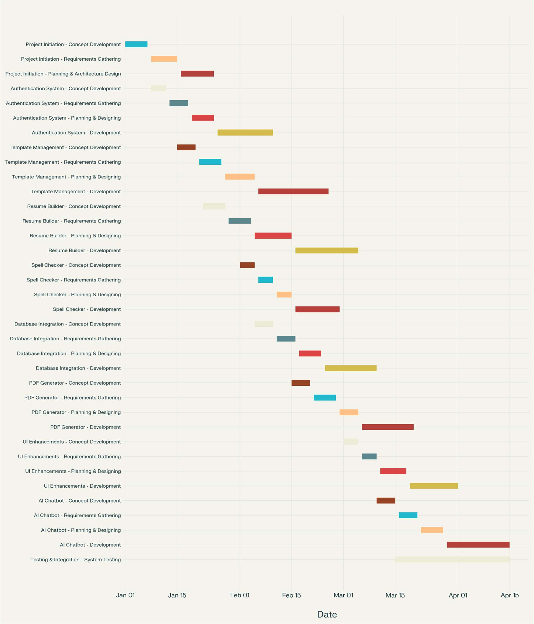

Understanding Gantt Charts in Agile Project Management
Despite traditional associations with Waterfall methodologies, Gantt charts have proven valuable within Agile frameworks when implemented strategically. A Gantt chart is fundamentally a visual project management tool that illustrates tasks and their timelines within a project workflow, typically featuring

three core components: a list of tasks, a timeline, and schedule bars representing task durations[1]. For the EzResumeCraft project, this visualization tool serves as a high-level roadmap that complements the iterative nature of Agile development.

Breaking the Waterfall Misconception
Contrary to common belief, Gantt charts are not exclusively suited for linear, phase-based project management. Modern Gantt charts offer dynamic capabilities including real-time progress tracking, sprint alignment, and cross-functional visibility without compromising core Agile principles[2]. This adaptability makes them particularly valuable for projects like EzResumeCraft that require both flexibility and structured timelines.

Benefits in an Agile Environment
The integration of Gantt charts within EzResumeCraft's Agile development brings several key advantages:

- Enhanced Visibility: The chart maps out epics, sprints, and dependencies for a more precise project timeline, allowing team members to check progress at a glance[3].
- Proactive Risk Management: By visualizing the entire development lifecycle, the team can identify potential bottlenecks and resource constraints before they impact development[2].
- Stakeholder Communication: Gantt charts provide executives and clients with a high-level overview that communicates complex project timelines in an accessible format[2].
- Long-term Planning: While Agile focuses on short iterations, the Gantt chart helps align these sprints with the long-term product roadmap for EzResumeCraft[4].

EzResumeCraft's Gantt Chart Implementation
The EzResumeCraft project utilizes a Gantt chart specifically tailored to its Agile development lifecycle, with key phases mapped to timelines that balance flexibility with structured planning.

Project Phases and Timeline
The Gantt chart for EzResumeCraft displays six critical development phases:

- Concept & Requirement Gathering (April 1-7, 2025): Identifying project objectives, target user personas, and key functionalities[5].

- Planning & Design (April 8-14, 2025): Developing flexible system architecture suited for responsive web design and creating wireframes and UI/UX prototypes[5].
- Development (April 15-May 15, 2025): Implementing core features using modern web technologies and integrating AI assistance for content generation[5].
- Testing (May 16-31, 2025): Conducting usability testing, functional and performance tests, and security audits[5].
- Deployment (June 1-7, 2025): Deploying early versions of the platform through continuous delivery on Netlify[5].
- Feedback & Continuous Improvement (June 8-30, 2025): Gathering real-time feedback from beta users and incorporating enhancements in subsequent sprints[5].

Integration with System Architecture
The Gantt chart serves as a visual roadmap that complements EzResumeCraft's comprehensive system architecture. This architecture includes:
- Frontend (Client): A React.js application with Tailwind CSS for responsive styling, Material UI for prebuilt components, and ShadCN UI for additional enhancements.
- Backend (Server): Node.js and Express.js API handling server logic and routing.

- Database & Caching: MongoDB for NoSQL database functionality and Redis for caching and session management.
The Gantt chart timeline aligns with the development sequence illustrated in the sequence diagram, showing how users will interact with various system components through processes like template selection, content editing, spell checking, and PDF generation.

Agile-Specific Adaptations
To maximize effectiveness within EzResumeCraft's Agile methodology, several adaptations have been made to the traditional Gantt chart approach:

High-Level Focus

The EzResumeCraft Gantt chart maintains a high-level perspective, showing important dates and activities without descending into task-level micromanagement[4]. This approach preserves the Agile value of team autonomy while providing necessary structure.

Expectation of Change
The development team acknowledges that the Gantt chart will evolve as the project progresses. They approach it as a living document that will require updates through continuous planning activities as priorities shift and new insights emerge[4].

Sprint Integration
Rather than tracking individual tasks, which would conflict with Agile principles, the EzResumeCraft Gantt chart focuses on sprint-level planning. This creates one task per sprint and accounts for dependencies between development phases[3].

Best Practices Implemented
The EzResumeCraft team follows several best practices in their Gantt chart implementation:

Daily Review
During daily standup meetings, the team reviews Gantt chart updates and makes adjustments where necessary, ensuring the timeline remains relevant to current development realities[3].

Dependency Management
The chart clearly identifies dependencies between phases, such as how testing cannot begin until core development reaches a certain stage. This visualization helps preemptively address potential bottlenecks[1].

Date Range Flexibility
Instead of rigid deadlines that could undermine Agile principles, the EzResumeCraft Gantt chart employs date ranges for major milestones, acknowledging the inherent unpredictability in software development[4].

Conclusion

The EzResumeCraft project demonstrates how Gantt charts can be effectively integrated within an Agile development framework when implemented thoughtfully. By maintaining high-level focus, embracing change, and focusing on sprints rather than individual tasks, the team leverages the visualization benefits of Gantt charts while preserving Agile flexibility.
This balanced approach provides enhanced visibility for stakeholders, supports proactive risk management, and bridges the communication gap between development teams and management. For projects like EzResumeCraft that combine creative design elements with technical implementation, a well- adapted Gantt chart serves as a valuable tool that complements rather than contradicts Agile methodologies.
As EzResumeCraft progresses through its development lifecycle, the Gantt chart will continue to evolve, reflecting the iterative nature of Agile development while maintaining a clear vision of the project's overall trajectory and timeline milestones.

